Story

Date | 16 Feb 2026
Team ID | LTVIP2026TMIDS25024
Project Name | Visualizing Housing Market Trends: An  Analysis of Sale Prices and Features using Tableau
Maximum Marks | 5 Marks

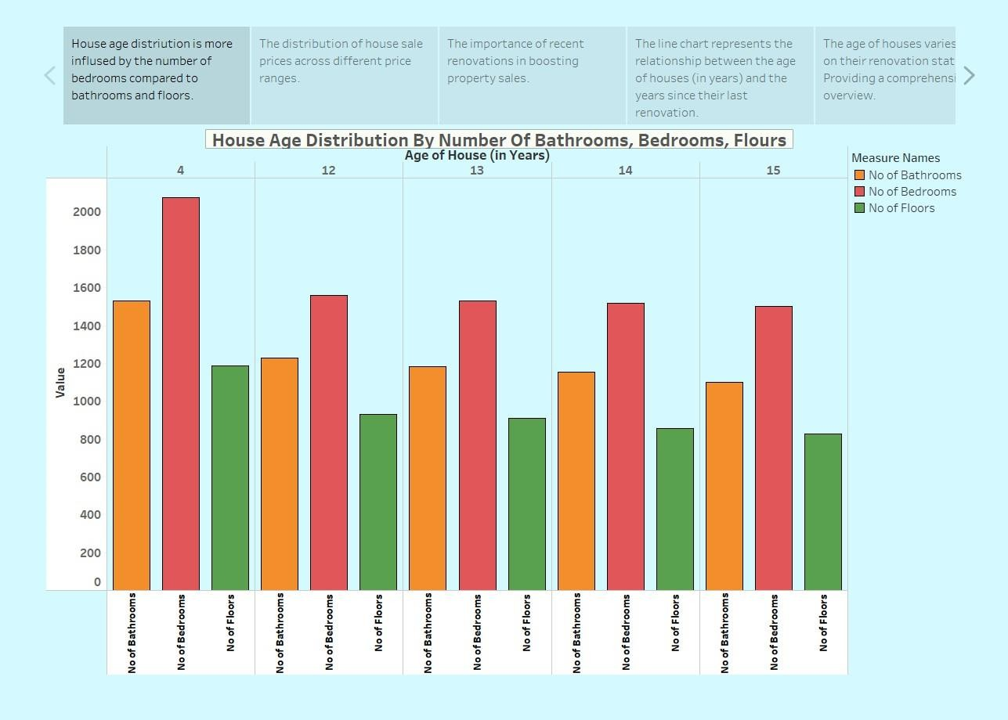

Observations:
- Bedroom Count Dominates – The number of bedrooms (red bars) has a higher
distribution than bathrooms (orange) and floors (green) across all house ages. This suggests that house age distribution is more influenced by bedroom count.
- Consistent Pattern Across Ages – The pattern remains relatively stable for different house ages (4, 12, 13, 14, 15 years), indicating no sudden shifts in bedroom,
bathroom, or floor counts over time.
- Potential Influence of Renovations – Since the chart mentions renovation trends, it's possible that houses with higher bedroom counts have undergone more modifications over time.

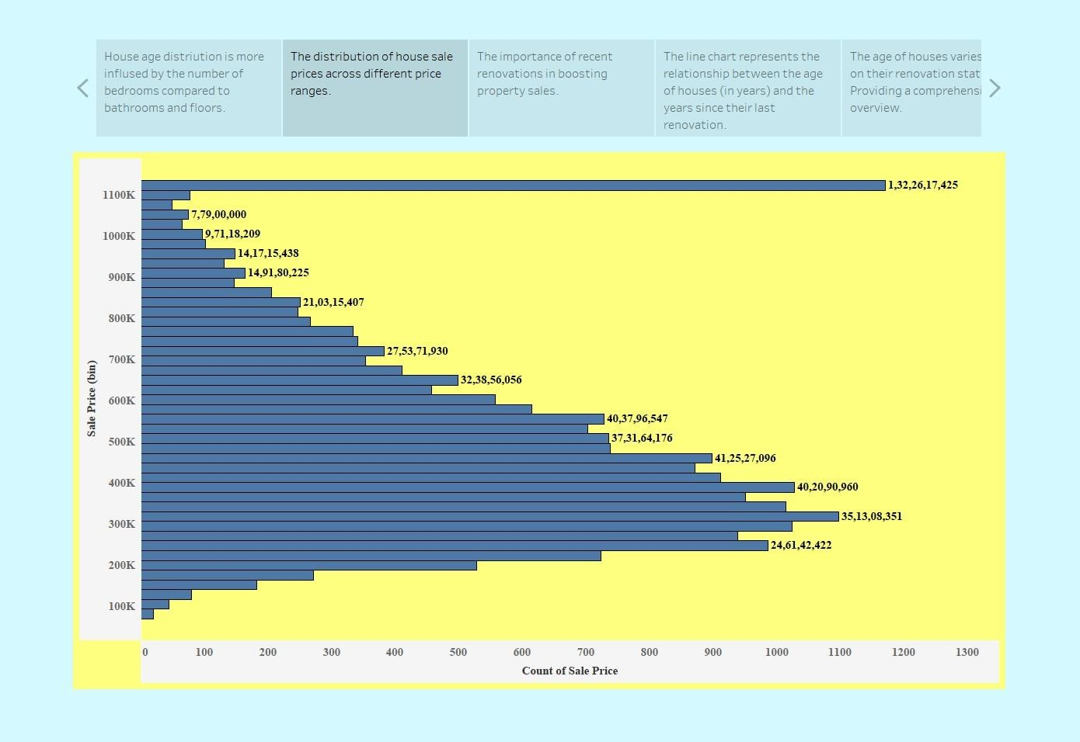

Observations:

- Most Common Sale Prices – The highest concentration of house sales falls in the range of 300K to 500K, with 500K being the most frequent sale price range.
- Right-Skewed Distribution – The chart exhibits a right-skewed trend, meaning that
lower-priced homes are more commonly sold, while high-priced homes are rarer.
- Extreme High-Value Outlier – There is a significant outlier at 1.32 million, which suggests the presence of a few ultra-expensive properties.

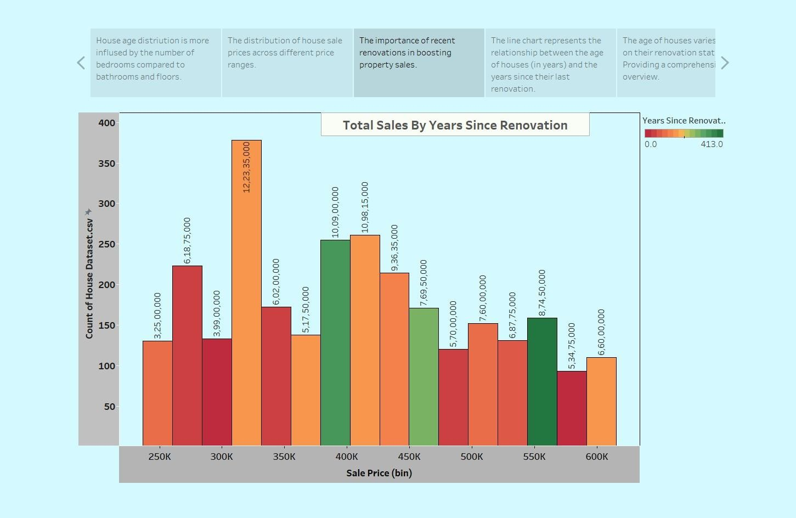

Observations:

- Peak Sales at 300K – The highest number of sales occurs at the 300K price range, indicating strong demand for affordable houses.
- Renovated Houses Sell More in Certain Price Ranges – The 350K and 400K price bins show a high number of sales where houses have been renovated recently
(represented by lighter colors).
- Sales Decline as Prices Increase – Similar to previous charts, the number of sales gradually decreases beyond 450K, indicating that fewer people purchase expensive homes.

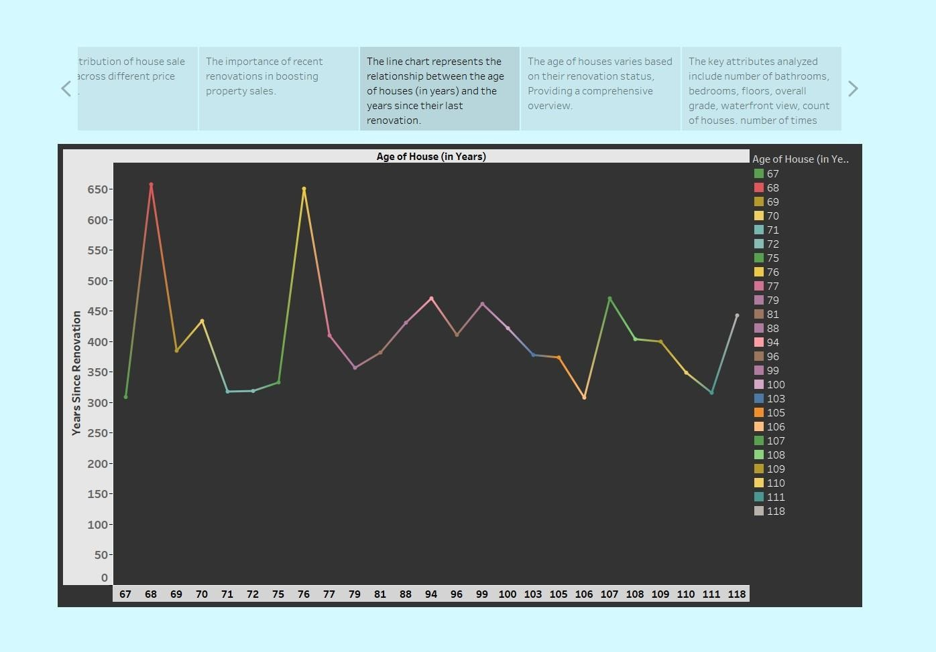

Observations:

- Older Houses Have Longer Time Since Renovation – Houses that are older tend to have a higher number of years since their last renovation. Some points in the dataset indicate houses that haven't been renovated for over 600 years, which may be a data anomaly or an extreme case.
- Clusters of Recently Renovated Houses – Some houses, even with significant ages, show lower years since renovation, meaning they have been maintained or upgraded more recently.
- Extreme Peaks Indicate Outliers – The highest spikes may suggest that some very old houses have never been renovated, or the data might have inconsistencies in
renovation records.

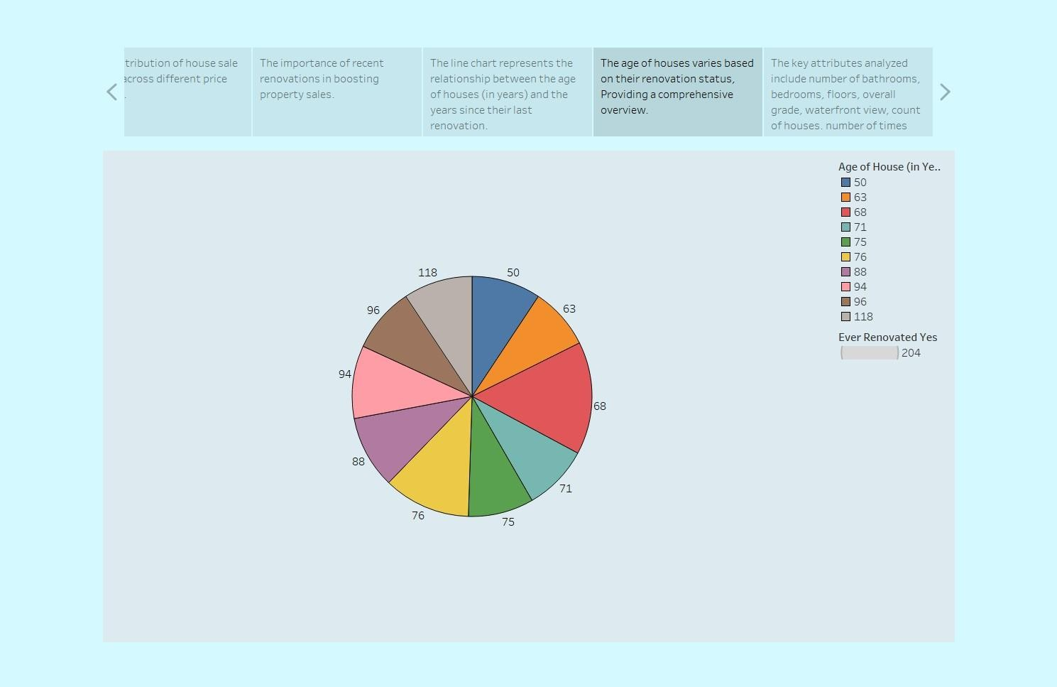

Observation:

- Even Distribution of House Ages – The chart shows a relatively balanced distribution of houses across different age ranges, with no single age group overwhelmingly dominating.
- Older Houses (100+ Years) Have a Noticeable Presence – Houses aged 96 and 118 years occupy significant portions of the pie, suggesting a notable number of older homes in the
dataset.
- Majority of Houses are 50-100 Years Old – Most houses fall within the 50 to 96-year range, implying that mid-aged homes make up a significant part of the dataset.
- Renovated House Count is Highlighted – The 204 houses that have been renovated suggest that a substantial portion of homes in the dataset have undergone upgrades or maintenance at some point.

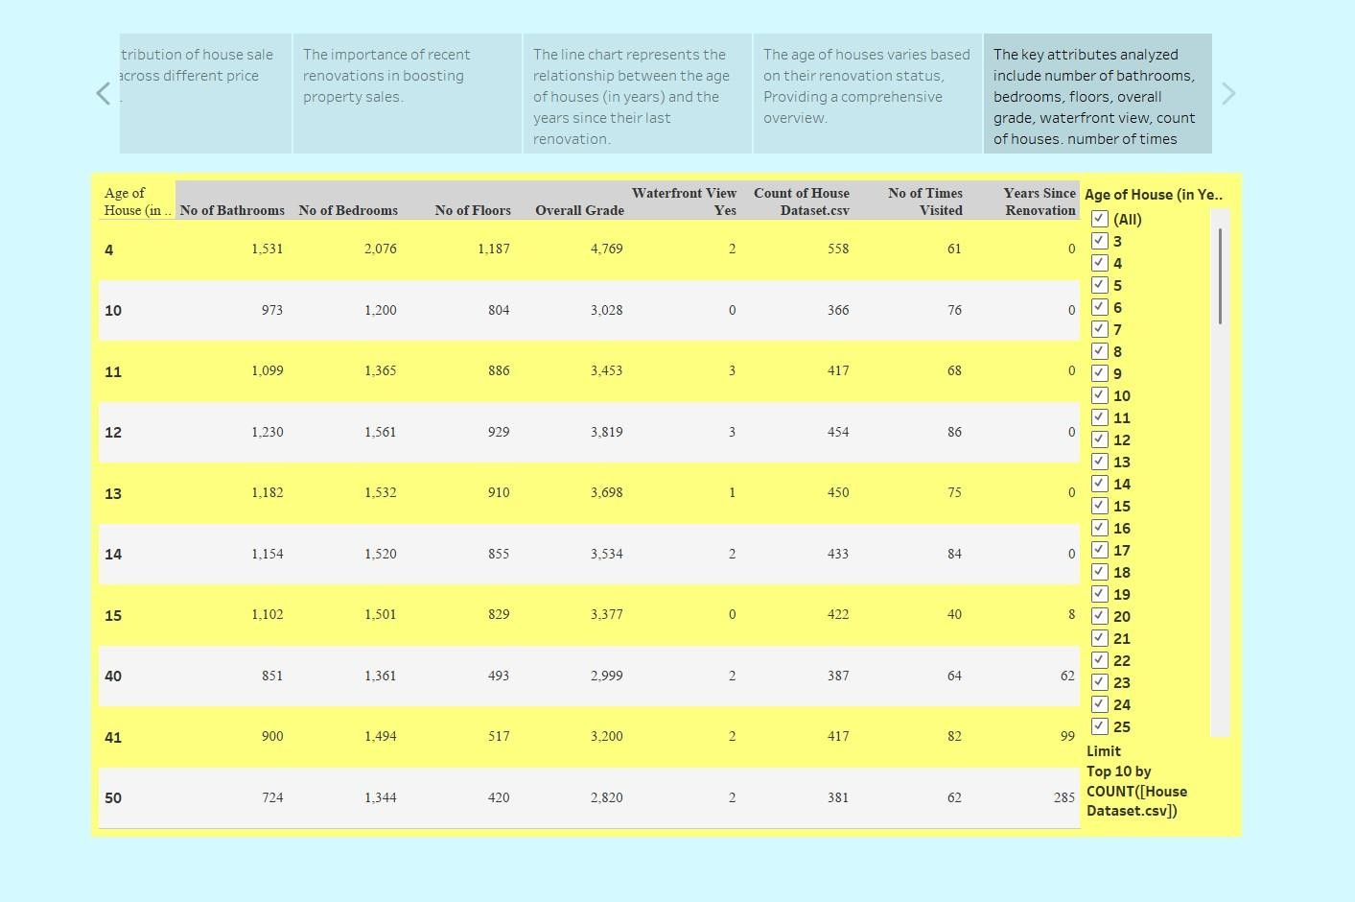

Observations:

- Newer Houses are More Frequent in the Dataset – The table lists house ages from 4 to 50 years, indicating that newer homes (under 50 years old) are well-represented in
the dataset.
- Overall Grade Decreases with Age – The overall grade of houses tends to decline as the house age increases (e.g., 4-year-old houses have a grade of 4,769, while 50-
yearold houses have 2,820), suggesting that older houses may have lower quality or fewer modern upgrades.
- Waterfront Views are Limited – Very few houses have a waterfront view (values range from 0-3 per house age group), suggesting that such properties are rare in the dataset.
- Count of Houses Decreases with Age – The number of houses recorded in the dataset reduces as the house age increases. For example, there are 558 houses aged 4 years,
but only 381 houses aged 50 years.

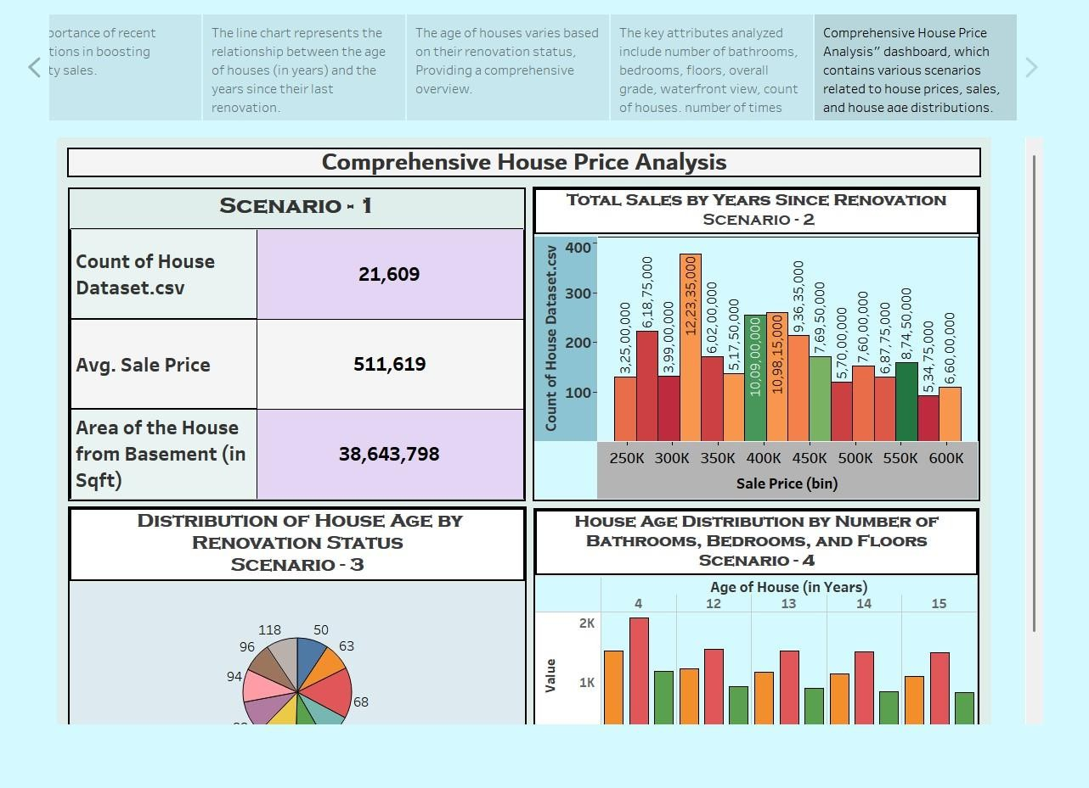

Observation:

Scenario 1 - Dataset Overview
- The dataset contains 21,609 houses.
- The average sale price is $511,619.
- The total house area (including basements) is 38,643,798 sqft. Scenario 2 - Total Sales by Years Since Renovation
- The highest number of sales occurs in the $350K price range, indicating this price bracket is the most preferred.
- The $250K and $600K price bins have the least number of sales, suggesting lower demand for both cheaper and premium-priced houses.
- The $400K and $450K price ranges show moderate sales, indicating a balanced market in this segment.

Scenario 3 - Distribution of House Age by Renovation Status
- The pie chart shows that houses have varying renovation statuses.
- Different age groups of houses exist, with no single age dominating the dataset.
- Some houses are older but still renovated, which could imply that renovations boost house value and marketability.

Scenario 4 - House Age Distribution by Bathrooms, Bedrooms, and Floors
- Houses around 4 years old have the highest count in terms of the number of bathrooms, bedrooms, and floors.
- The number of bathrooms appears to have a significant impact on house distribution.
- Houses aged 12 to 15 years have a more balanced distribution across different parameters, suggesting these are still competitive in the market.

